

MAT 2002 DA-2



Name: pranay agrawal

Registration no: 22mis0172

**Experiment 2A:**

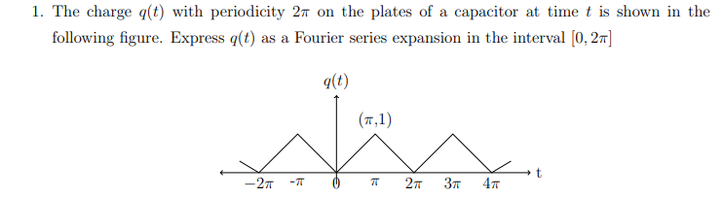

**Code:**

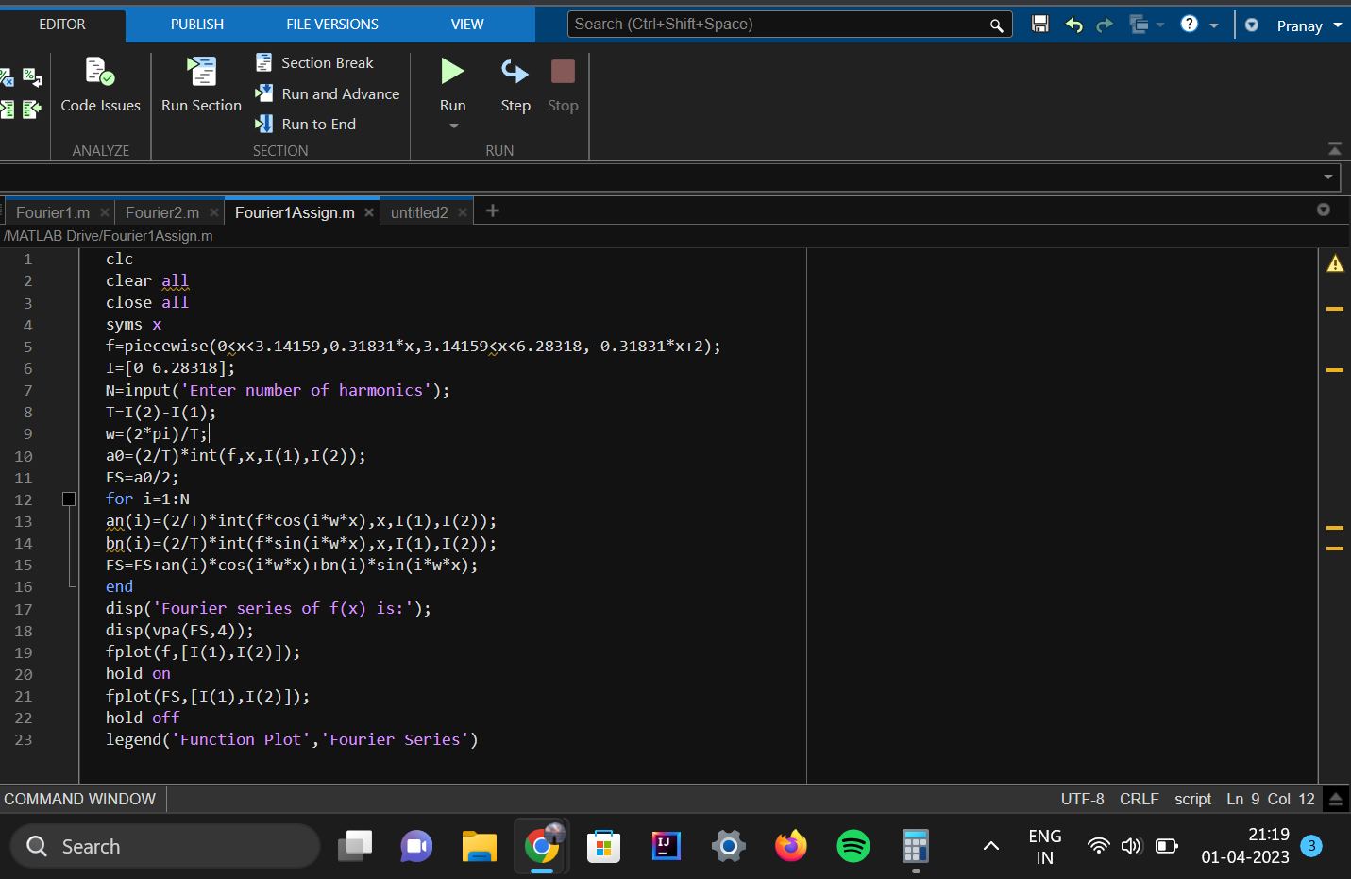

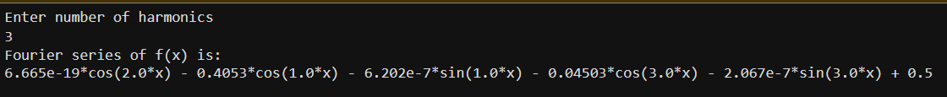**Output:**

**Function Plot:**

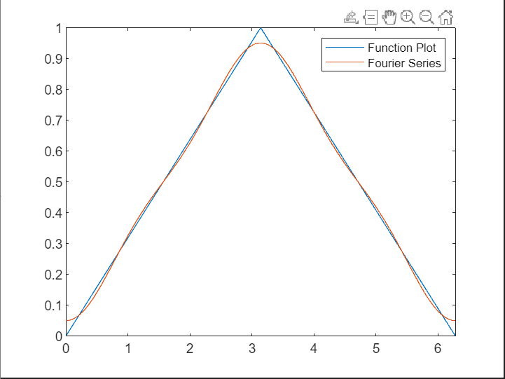

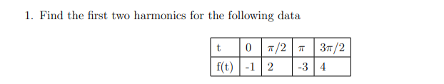**Experiment 2B:**

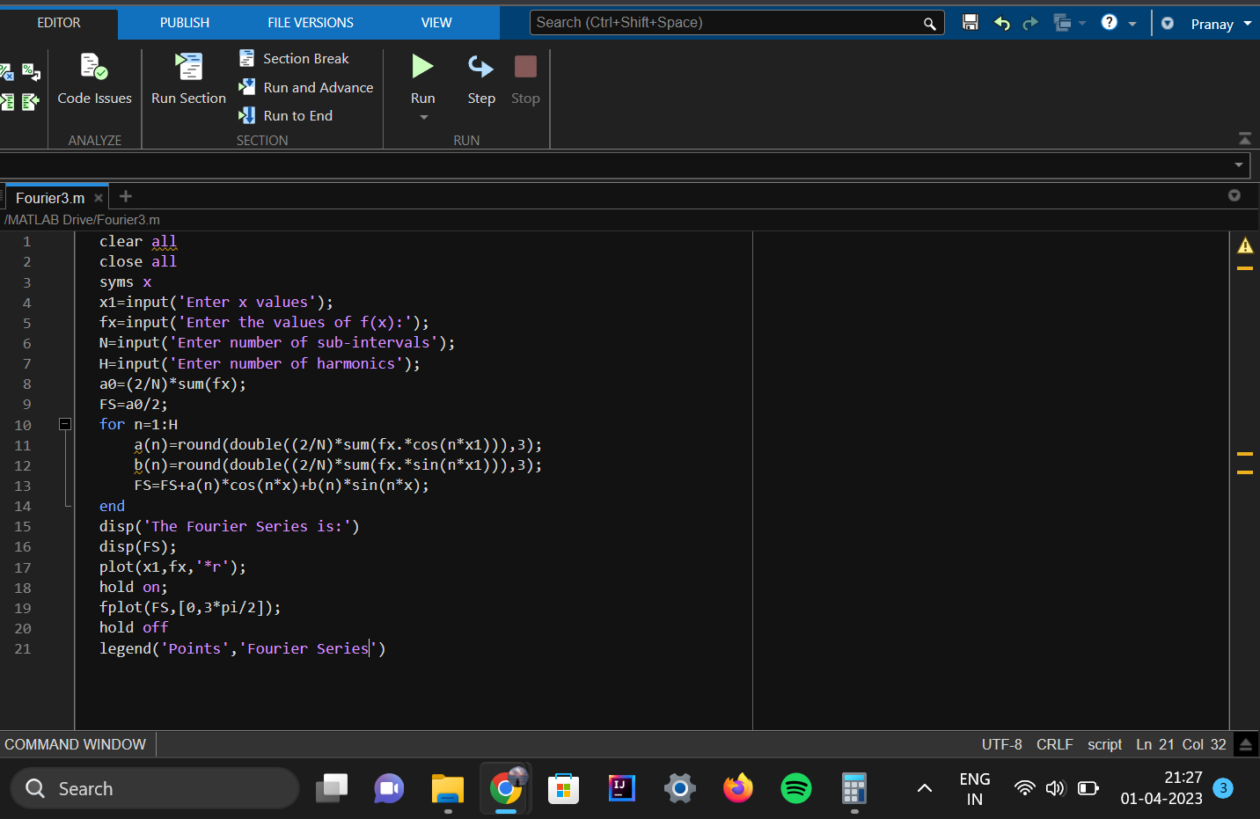**Code:**

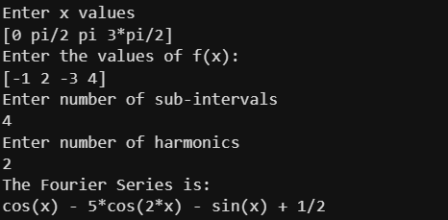**Output:**

**Function Plot:**

